**EECS 338**

***Today...***

1. **Review pipes**
2. **Review sockets**
3. **Threads in C**

**Announcements**

* Friday: **NO CLASS**
  + Chris will be here: <https://sigcse2018.sigcse.org/>
* HW #4 due tonight
* Quiz #4 due Thursday night (will be posted tonight)
* HW #5 posted (due Tuesday)
  + Includes new versions of server.c and client.c

**Pipes Review**

* See separate slides (Pipes – slides only.pptx)
  + Also: <https://youtu.be/Xidunu_-I5I>
* Question from Monday: does “read” wait/block?
  + Answer: yes

**Sockets in C**

* IMPORTANT: HW #5 includes new versions of server.c and client.c

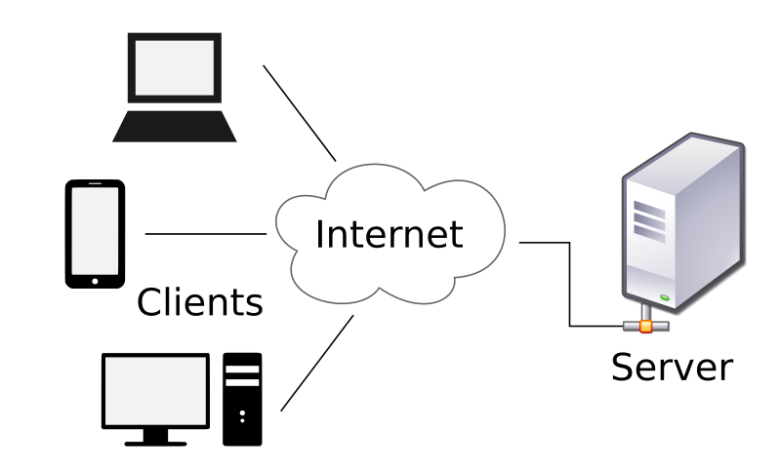

Image source: commons.wikimedia.org

**General steps**

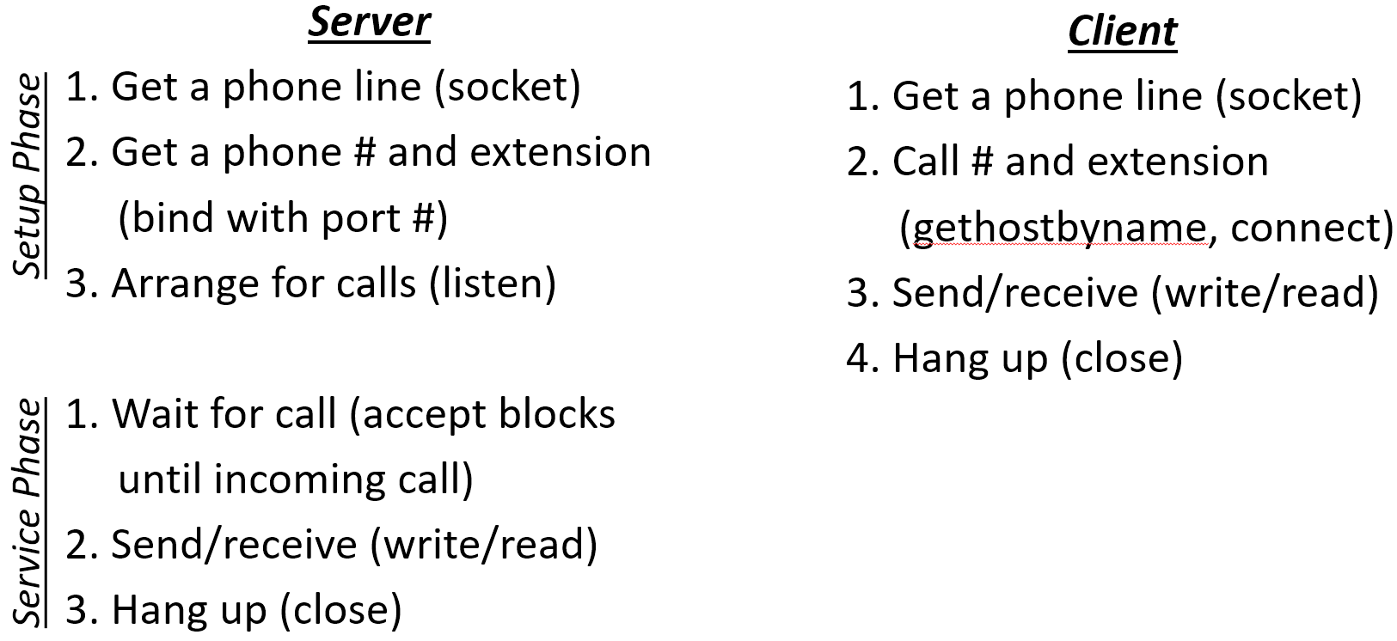

* Using separate servers: server.c, client.c
  + Example: eecslab-1.case.edu, eecslab-2.case.edu
  + Getting IP address
    - hostname -I
    - ifconfig
    - In a program:

<http://www.binarytides.com/hostname-to-ip-address-c-sockets-linux/>

* + If you’re curious about the structs (not required)

<http://man7.org/linux/man-pages/man7/ip.7.html>

**Lots of Links**

<http://man7.org/linux/man-pages/man2/socket.2.html>

<http://man7.org/linux/man-pages/man2/listen.2.html>

<https://linux.die.net/man/3/htons>

The htons() function converts the unsigned short integer hostshort from host byte order to network byte order.

<https://en.wikipedia.org/wiki/Endianness>

**Threads in C (Ch 4)**

thread: <https://en.wikipedia.org/wiki/Thread_(computing)>

|  |  |
| --- | --- |
| The smallest sequence of programmed instructions that can be managed independently by a scheduler. In most cases a thread is a component of a process. Multiple threads can exist within one process and share resources such as memory, while different processes do not share these resources. In particular, the threads of a process share its instructions (executable code) and its context (the values of its variables at any given time). |  |

Examples:

gcc -o threads1 threads1.c –lpthread

<http://man7.org/linux/man-pages/man3/pthread_attr_init.3.html>

threads2.c